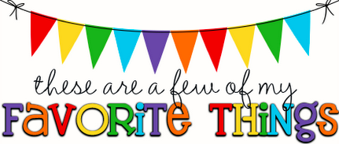
Ana Stathis  Dual Language Assistant | Birthday: 04/27
Favorite Color | Blue/Black
Drink | Starbucks:  Sonic: Cherry limeade
Snacks | Sweet: Chocolate  Salty:
I Would Love Gift Cards To: | Restaurants: Olive Garden  Shopping: Marshalls
Hobbies, Interests, Ways I Treat Myself | Beauty Salon
Favorite Sport or Team | Swimming/Volleyball

